SACRED HEART PARISH

Sacred Heart Parish Founded 1814, The First Catholic Parish in the STate of New Jersey

Sacred Heart Church, 343 South broad Street, Trenton, New Jersey 08608

Holy Cross Church, 233 Adeline Street, Trenton, New Jersey 08611

ALL ARE WELCOME

Whatever your present status in the Catholic Church, whatever your current family or marital situation,

Whatever your past or present religious affiliation, whatever your personal history, age, background, or

race, whatever your own self-image or esteem, you are invited, welcomed, accepted, loved and

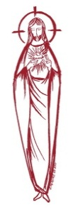
respected at the Parish of the Sacred Heart.

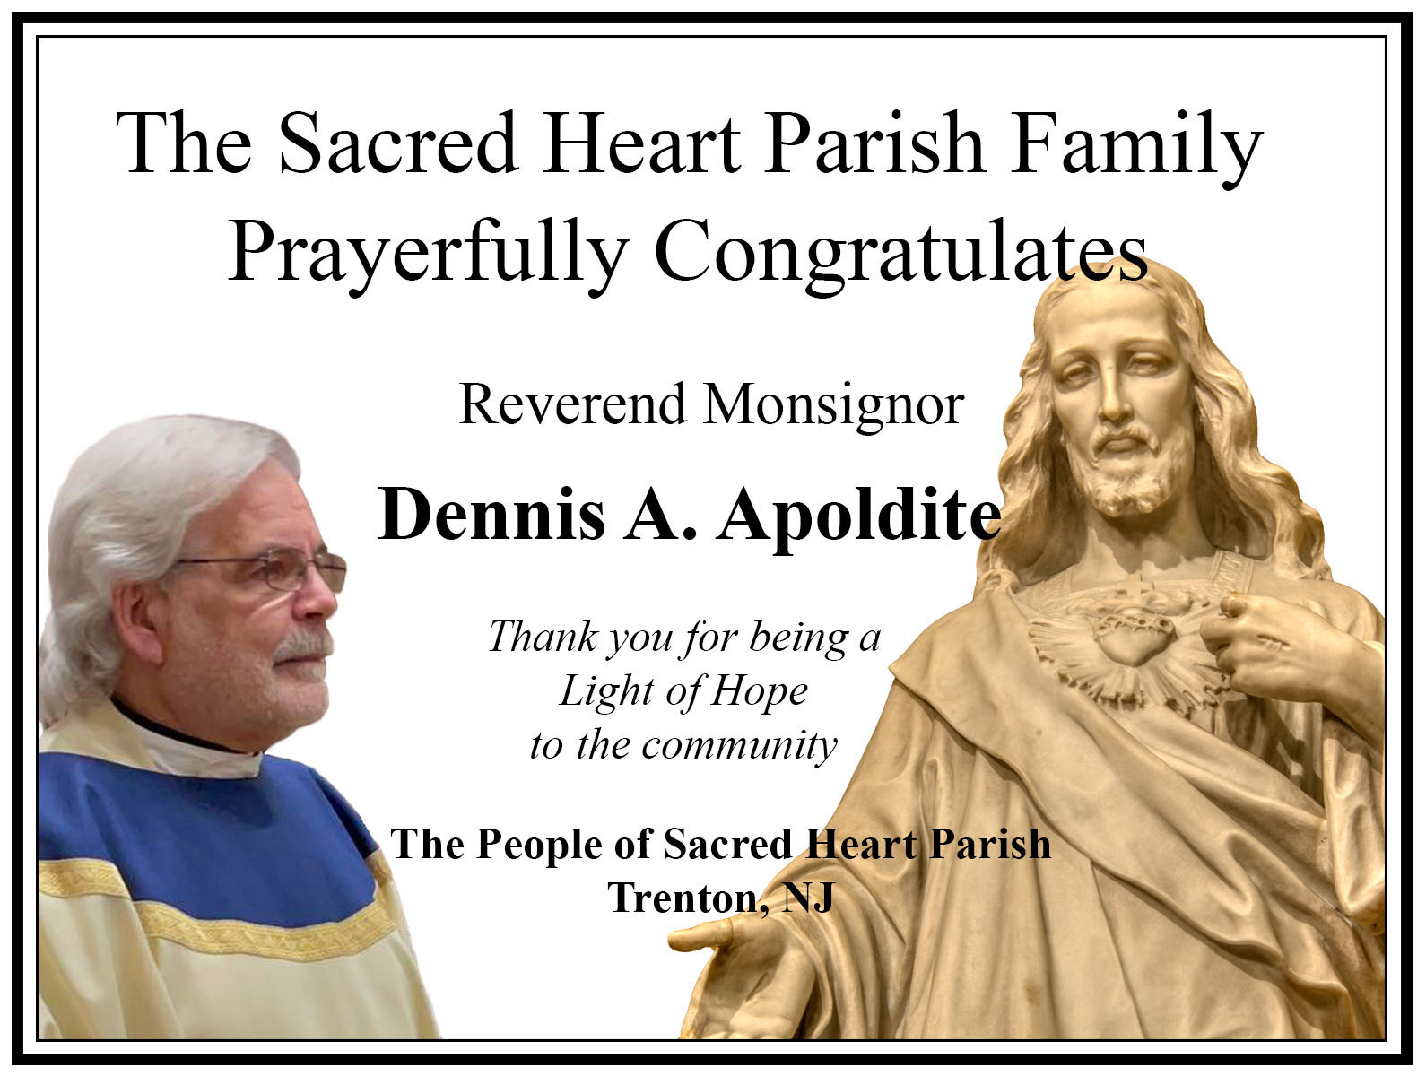

TWENTY-THIRD SUNDAY
IN ORDINARY TIME
September 17, 2023

MASS INTENTIONS
Saturday, September 16
4:00 pm ~ Roger Kuhns
5:15 pm SHC ~ Patricia Willever
Sunday, September 17
9:00 SHC ~ Andrea and Florence Hoch
10:00 HCC Intentions of the People of the Parish 11:15 SHC ~ Brijida Vargas
12:00 HCC Polish ~ Jan Zak
Monday, September 18
8:00 am HCC ~ Special Intentions
12:10pm SHC ~ John Matthews
Tuesday, September 19
12:10 pm SHC ~ Miguel Edralin
Wednesday, September 20
12:10 pm SHC ~ Eileen Kostrzewa
Thursday, September 21
8:00 am HCC ~ For the Sick of our Parish
Friday, September 22
8:00 am HCC ~ For Vocations
12:10pm SHC ~ Yvonne Humphrey
Saturday, September 23
4:00 pm ~ Glazewski Brothers and Shelby Rowe
5:15 pm SHC ~ Gerald Apoldite and
Brenda Southwick
Sunday, September 24
9:00 SHC ~ Louis and Helen Beckett
10:00 HCC ~ For the People of the Parish
11:15 SHC ~ Ken and Donna Kuebler
12:00 HCC Polish ~ Maria Bonna

OUR SICK LIST
Lorraine Wargo, Robert Paci, Mrs. Loatman, David Carver, Gertrude Siber, Jennifer Lyons, Grace Profy, Steve Jurczynski, Trudy Breuer, Cornell Hess, Ruby Covington, Judith Santigo, Ching Kukis, Dan Breese Jr, Brenna Kennedy-Moore, Dawn Chia, Mark Friedman, Alexander A. Ladnyk, Kelly Nitti, Lauren Clayton, Joseph Edralin, Margie Tiongson, Kevin, Vincent Cooper, Jr., Gail Ladnyk, Leo Genovesi, Sloane Donnelly, Richard Buckley, Tony Ragolia, Barbara Burrows, Robert Mahon, Charles Burrows, Dorothy Amoroso, Maryann Sullivan, Regina Friedman, Rita Mich, Stanley Winowicz, Greg Schafer, Jack Hardiman, Amy Birk, Julia Grazioli, Matt Tydryszewski.
OUR DECEASED

Ronald Carver, Anthony Burzachiello and our friends at South Village, Riverside Nursing and Rehabilitation Center, Mill House and Waters Edge.

MINISTRY SCHEDULE
(subject to change)
Saturday, September 16
4:00pm HCC ~ Fr Charles L. V Zielinski Em. R Micharski
5:15pm SHC ~ Msgr. Dennis L. C Hernandez Em. A Solack J Breuer
`Sunday, September 17
9:00 SHC ~ Msgr. Dennis L. A Urbaniak Em R&K Figueroa
10:00 HCC ~ Fr. Charles L. F Kollie Em F Kollie
11:15 SHC ~ Msgr. Dennis L. J Rhodes Em J Diaz, S Jurczynski
12:00 HCC Polish ~ Fr Marian

Saturday, September 23
4:00pm HCC ~ Fr Charles L. C Benitez Em. L Bliznawiczus
5:15pm SHC ~ Msgr. Dennis L. N Kazior Em. J Kazior B DuMont
Sunday, September 24
9:00 SHC ~ Msgr. Dennis L. F Zielinski Em A Green W James
10:00 HCC ~ Fr. Charles L O Nnadi Em G Mowenn
11:15 SHC ~ Msgr. Dennis L. M Rhodes Em N Rhodes M Otriz
12:00 HCC Polish ~ Fr Marian

WEEKLY COLLECTION
Last weekend’s collection amounted to $8,673.00 and for Catholic University $580.00. This includes the donations received in Church and the mail ins. Thank you for your continued support of our parish.

2023 ANNUAL CATHOLIC APPEAL UPDATE
Goal: $33,000.00 :
Pledged: $44,561.00 (135% of Goal)

READINGS FOR THE WEEK
Twenty-fourth Week in Ordinary Time
Sunday Sir 27:30—28:7; Rom 14:7-9; Mt 18:21-35
Monday 1 Tm 2:1-8; Lk 7:1-10
Tuesday 1 Tm 3:1-13; Lk 7:11-17
Wednesday 1 Tm 3:14-16; Lk 7:31-35
Thursday Eph 4:1-7, 11-13; Mt 9:9-13
Friday 1 Tm 6:2c-12; Lk 8:1-3
Saturday 1 Tm 6:13-16; Lk 8:4-15

PROMISE TO PROTECT
The Diocese of Trenton is committed to the norms of the U.S. Bishop’s Charter for the Protection of Children and Young People in regard to the reporting and investigation of sexual abuse allegations involving minors. If you have been sexually abused as a minor by anyone representing the Catholic Church, you can report that abuse through the diocesan Hotline: 1-888-296-2965 or via e-mail at abuseline@dioceseoftrenton.org. Allegations are reported to the appropriate law enforcement agencies.

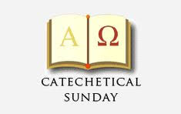
Today the Parish of the Sacred Heart joins our country in celebrating Catechetical Sunday. Those whom the community has designated to serve as catechists will be called forth to be commissioned for their ministry. Catechetical Sunday is a wonderful opportunity to reflect on the role that each person plays, by virtue of Baptism, in handing on the faith and being a witness to the Gospel. It is an opportunity for all to rededicate themselves to this mission as a community of faith. The Commissioning Ceremony for our Catechist and Aides will be held at the 9:00 AM Mass at Sacred Heart Church, they include:

Mary Tovar
Nancy Breece Milly Diaz
Kate Jurzynski Susan Jurzynski
Sharon Lauchaire Zoila Mendez
Charlotte Miller Maureen Rick
Jean Marie Perry Jill Pienciak
Michelle Valentino Ethan Vasquez
Christopher Vagnozzi Ed Wengryn

Prayer for Catechists
Loving God, Creator of all things, you call us to be in relationship with you and others.
Thank you for calling me to be a catechist, for the opportunity to share with others what you have given to me.
May all those with whom I share the gift of faith discover how you are present in all things.
May they come to know you, the one true God,
and Jesus Christ, whom you have sent. May the grace of the Holy Spirit guide my heart and lips,
so that I may remain constant in loving and praising you.
May I be a witness to the Gospel and a minister of your truth. May all my words and actions reflect your love. Amen.

O C I A – BECOMING CATHOLIC
The Order of Christian Initiation of Adults (OCIA) is the process by which non-Catholics enter the Roman Catholic Faith (Formally known as R C I A). To become a Catholic, one must understand the teachings of the Church, believe in those teachings, and be a baptized Catholic. Those who are not baptized will study the teachings through OCIA and conclude their journey with the reception of the Sacrament of Baptism into the Church. Those who were baptized as a Protestant will likewise study via OCIA and conclude their journey with their reception into the Church. You are invited to join us for our “Inquiry session” scheduled to begin this weekend September 17th at 10:00 am in the old Sacred Heart School building ( using the back door entrance). Please contact Msgr. Dennis at Frdennis@trentonsacredheart.org or 609-393-2801 ext. 102 to register before attending the sessions.

SENIOR’S GROUP
The Senior Group is welcoming All Seniors of the parish to meet this Wednesday, September 20th. Many of the group meet for the 12:10 PM Mass (optional) followed by a social gathering in Toomey Hall. Come enjoy a light lunch, meeting and enjoying each other’s company. We will be working on the calendar for the season. Our group meets on the first and third Wednesday of each month.

CAPITAL SINGERS OF TRENTON

HARMONY HARVEST

~ a Fall Fundraiser and season preview~

Join us for a cornucopia of food, fellowship

and musical delights.
Sep 24, 4:00 PM
In Msgr. Toomey Hall located under
Sacred Heart Church, 343 S Broad Street.
Food and beverage will be served, including wine, beer and soft drinks. Entertainment includes full chorus offerings as well as duets and solos. Season sneak peek preview by Artistic Director Vinroy D. Brown, Jr. Silent Auction and Wine Grab.
General admission ~ $75.00

RETROUVAILLE:
REDISCOVER THE LOVE IN YOUR MARRIAGE
Some couples feel lonely, frustrated, or angry in their marriage, often feeling shut off from one another. Other couples experience severe conflict and never-ending arguments. Retrouvaille offers hope for all these marriages by teaching couples to communicate in a deeper, more meaningful way, healing hurts and rebuilding trust and intimacy. No relationship is beyond help. The next program will be held October 6 - 8, 2023 at the Family Life Center in Malvern, PA. For more information, or to register, please call 215-766-3944 or 800-470-2230, or visit our website at www.HelpOurMarriage.org All inquiries are strictly confidential.

WEDDING ANNIVERSARY BLESSING
The Department of Evangelization and Family Life is pleased to announce the 2023 Bishop’s Anniversary Blessing for all couples celebrating a milestone anniversary of their Catholic Marriage. All couples celebrating their 1st, 25th or 50th (or more) anniversary in the 2023 calendar year are invited to attend. Anniversary couples must be validly married in the Catholic Church and registered members of a parish in the Diocese of Trenton. The Bishop’s Anniversary Blessing Mass for Mercer and Burlington County Parishes will be held on Sunday, October 22, 2023 at 3 pm in the Cathedral of St. Mary in Trenton. General information including online registration for anniversary couples can be found at www.dioceseoftrenton.org/bishops-anniversary-blessing.

UKRANIAN FOOD SALE
Fall is almost here and it's time for some comfort food! As always, our Sisterhood welcomes your orders for homemade pierogies and stuffed cabbage! Please consider placing an order (by Sept. 24), and tell your friends and neighbors. Please call Daria 609.585.7863 or Slava 609.585.1294, or email Marta juzeniwmarta@gmail.com to place your orders. Pickup date is Saturday September 30 at the Sisterhood of St. Josaphat's Ukrainian Catholic Church.
THE MIRACLE OF CHRISTMAS
SIGHT AND SOUND, LANCASTER
We have secured tickets for the Christmas Show in Lancaster PA for December 29, 2023 for the morning show at 11:00. More details will be given next week. We look forward to sharing the Christmas Spirit with you.

AUTUMN PRAYER
God of all seasons, we thank you for Autumn.
We thank you for the touch of coolness in the air that gives us a new burst of energy, for the coloring of trees that shows the creativity of the Divine Artist, for the falling leaves that reveal the strength of the branches, for the hues of fields that bring peace to our souls, for the smiles on pumpkins that bring joy to children, for the fall harvest which that brings us gratitude for the bounty of our land, for this change of seasons that reveals the circle of life. God of all seasons, as you transform the earth,
transform us by your Spirit. Amen

FRANCIS HOUSE OF PRAYER
Trenton Diocesan Spiritual Center
84 Walnford Road, Allentown, NJ 08501
Personal Retreat Days Wednesdays 9:30 am - 2:30 pm October 11 November 8 December 6 Not a series. Come to Francis House for silence, personal prayer and optional spiritual direction. The day begins and ends with a brief prayer together. Please bring your lunch. Come to as many as you can. Donation: $10; $40 with spiritual direction
A Heart-Centered Life - Zoom Only 8 Mondays 6:30 pm – 8:00 pm September 18 October 2, 16 & 30 November 6 & 20 December 4 & 18 Not one of us takes our vision for granted. Where would we be if we could not see? In Kevin O’Brien’s newest book, Seeing with the Heart, we have the opportunity to learn a myriad of ways to use our heart’s vision, to see God, to see life, to see others and to see ourselves ever more clearly! Led by Sr. Marie. Donation: $100

